Geometric alignments linking Early Neolithic monuments in mid-Sussex

Emergence of the Alignments

Research on the Pells Pool and Park in Lewes unexpectedly led to identification of a complex geometric network of alignments linking the Neolithic monuments centred on the Ouse and Cuckmere estuaries. The alignments in turn may indicate the site of a previously unidentified long barrow close to the Pells.

The Pells Pool, opened in 1861, initially relied on water from a tangle of short streams running north and east from the spring line between the downland chalk and the alluvium of the river valley [1]. One spring, now built over and historically known as St John’s Well, lay just beyond the southeast corner of the Pells Park. It was almost certainly sacred from prehistoric times, since the chalk promontory, that looms over it, was once marked by a series of large pre-Christian mounds grouped along its western edge [2]. Lewes’ first church was built near the tip of the promontory between the southernmost mounds and the spring line, probably in the late 7th or early 8th century. Like many early churches beside pagan monuments, it was dedicated to Saint John the Baptist, whose baptismal associations were appropriate at a time of mass conversion to Christianity, but he was also strongly identified with the summer solstice. His saint’s day on 24th June is the traditional Mid-Summer’s Day and widespread medieval celebrations on St John’s Eve derived from pagan practices.

The health benefits of the sacred spring depended largely on summer sunshine. Drinking calcium rich water, that has filtered through chalk, helps build strong teeth and bones especially in growing children, but the process must be activated by hot sunlight falling directly onto the skin, which creates Vitamin D and aids absorption. Sunlight would once have reached the spring below the promontory in about April as the weather grew warmer.

The churchyard area above is well placed for tracking the entire year’s sunrises along the visible crest of the Cliffe Hills, the collective name for the small, isolated block of downland that entirely fills the eastern horizon beyond the river. The summer solstice sunrise appears midway down Malling Hill, at the northern end of the range, and six months later the winter solstice sunrise was formerly visible at the southern end, midway down the Ranscombe shoulder, a view now blocked by buildings.

The full moon follows a reversed pattern, rising from the Southerham end at mid-summer and the Malling end at mid-winter, but oscillations in its orbit, that follow an 18.6-year cycle mean that it rises and sets well inside the range of sunrises and sunsets at what is known as the minor lunar standstill, and well beyond the solar range at the major lunar standstill. Whether moonrise at the major standstill was once visible at the extreme lower edges of the hill formation or had moved beyond them is unclear.

The flatter western horizon culminates in a partly quarried away Neolithic causewayed enclosure, in a position just visible among encroaching woodland at an angle of about 315°NW from the St John’s promontory. It is sited just where the profile of Offham Hill starts to dip down towards the Weald and the setting sun at the summer solstice falls well short of it, but the setting mid-winter moon at the major lunar standstill may reach it. The next opportunity to test this will be in April 2025. Across the river valley the Offham enclosure faces a Neolithic long barrow on Cliffe Hill. Known now as the Camel’s Humps, after antiquarians scooped out the middle, and previously known as the Warrior’s Grave, it is conspicuous as a double mound on the skyline when seen from St John’s churchyard and much of historic Lewes. The mid-winter full moon may rise from the site of this barrow at the minor lunar standstill when seen from the promontory.

Examining these two monuments’ relationship with similar Neolithic monuments in the area revealed a complex geometric arrangement of rectilinear and circular alignments that are sufficiently repetitive to indicate that they were intentional. Initially, straight alignments between three or more sites were identified, but others involving only two sites often run parallel to them. Eventually a pattern of circles was also recognised, that linked all the monuments in a sufficiently precise way to suggest that surveying methods involving triangulation were used to position them accurately in hilly terrain. It may now provide a means of validating questionable monuments and recognising overlooked ones.

Circular Alignments

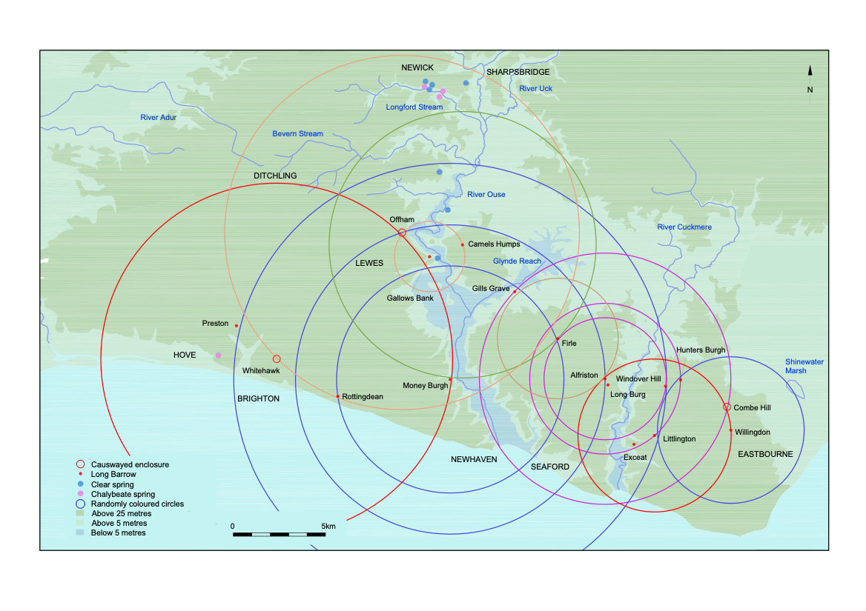
Figure 1 Selected circles, each centred on one monument, with two other monuments on the circumference.

Table 1. Illustrated* and unillustrated circles, listing central monuments first.

Alfriston oval barrow,
inner circle* – Firle and Windover
middle circle* - Hunters Burgh and Litlington
outer circle* – Combe Hill and Gills Grave
Camel’s Humps* – Firle and Money Burgh
Firle,
inner circle* – Gills Grave and Alfriston oval barrow
outer circle – Exceat and Hunters Burgh
Gallows Bank* – Camel’s Humps and Offham
Gills Grave – Alfriston oval barrow and Offham
Hunters Burgh – Long Burgh and Willingdon
Litlington* - Combe Hill and Willingdon
Long Burgh,
inner circle – Firle and Hunters Burgh
outer circle – Gills Grave and Willingdon
Money Burgh,
inner circle* – Firle and Rottingdean
middle circle* – Alfriston oval barrow and Offham
outer circle* – Litlington and Preston
Offham* – Rottingdean and Whitehawk
Whitehawk* – Money Burgh and Offham
Willingdon* – Hunters Burgh and Litlington
Windover – Combe Hill and Exceat

Nineteen circles have so far been identified. They overlap too densely to illustrate fully, but the majority are shown in Figure 1, and all are listed in table 1. Each monument forms the centre of a circle, excepting Combe Hill, Exceat, Preston and Rottingdean which are sufficiently close to the sea for coastal erosion to be a factor, and each circle has two other monuments sited on or close to the circumference. Where monuments are not quite on the rim, it may mean that the locations of destroyed or conjectured barrows are inexact, or it may indicate that aspects of the terrain, like the direction a ridge was running, led to some displacement. However, where sites are closely grouped both circles and rectilinear alignments often differentiate between them very precisely. Two barrows, Alfriston oval barrow and Money Burgh, are each ringed by three concentric circles, while the Firle barrow and the Long Burgh at Alfriston each have two rings. For the purposes of this article no distinction is made between long and oval barrows other than to avoid confusion over the pair of barrows at Alfriston.

The circles cover the three coastal blocks of downland traversed by the Ouse and Cuckmere rivers, up to and marginally beyond the watershed with the Adur at Ditchling and probably extending into low lying marshier areas further southeast and southwest, if questionable barrows are included. To the south the circles reach beyond the present coastline and to the north they extend into the Weald, where they seem to focus on specific parts of the rivers. The outer concentric circle centred on Alfriston oval barrow reaches up the Cuckmere to just beyond the confluence with a tributary at Wick Street. The entire headwaters of Glynde Reach fall within the circles while a large circle round Offham causewayed enclosure takes in the Ouse’s confluence with the Uck but stops short of another tributary just beyond Sharpsbridge which was possibly the navigable limit. Neither the post-medieval Wealden Iron industry nor 19th century canalisation, with all their resources managed to keep the river open for transport far beyond this point for any length of time [3].

Within the top of the circle just south of Newick is a combined cluster of iron-rich chalybeate springs and clear water springs. This suggests that the rusty looking water was already recognised for its curative properties for conditions such as anaemia and may also explain the entire inclusion of two major western tributaries of the Ouse within the circle. Longford Stream’s catchment area lies primarily in the iron bearing regions, in contrast to the Bevern Stream whose headwaters originate in the chalk. The two streams join the main river near Barcombe, within reach of the tide which introduced another important mineral, salt. Their merging in the Ouse may have been considered symbolic. The post medieval cults of drinking sea water and iron-rich water, that brought prosperity to Brighton and Tunbridge Wells respectively, probably derived from enduring folk medicine, while the more palatable calcium-rich water from chalk springs simply continued in use as everyday drinking water.

Other water features mark the circles’ reach to the east and west. Whitehawk’s circle includes the unusual phenomenon of a chalybeate spring emerging through the chalk at St Anne’s Well, Hove. To the east, another possible long barrow that appears to be reworked into a medieval moot at Willingdon [4], forms the centre of a circle with Windover Hill and Litlington on its rim. Also on the rim is Shinewater Marsh, now noted for Late Bronze Age associations [5], but possibly also important in the Neolithic.

Authentication of Neolithic Barrows

The conjectural Willingdon barrow can be paired with the Combe Hill enclosure on the rim of a circle centred on the Litlington barrow. The credentials of the Windover barrow have been queried because of its role within a post medieval quarrying complex [6], but it is well integrated within the framework of other Neolithic monuments and alignments, so it was presumably repurposed. At Preston, on the west of the monuments’ range a reported long barrow destroyed by road improvements in 1891-2 [7] seems to be associated with Money Burgh’s outer circle and contributes to the pattern of rectilinear alignments shown in Figure 3. When this formula is applied to the sites of lost mounds on St John’s promontory at Lewes, it suggests that a feature historically known as Gallows Bank, was probably a long barrow among a group of later round barrows. The monument’s length is uncertain, but it was positioned towards the southern end of a thin 100 metre long, wedge-shaped strip of land on the west side of the present Abinger Place. The conjectural barrow would form the centre of an unusually small circle with the Offham enclosure and the Camel’s Humps on its rim, and though it does not feature on the rim of a circle round another relevant monument, coastal erosion may be a factor. A rectilinear alignment between Preston and the Camel’s Humps does cross the Gallows Bank. Buildings now occupy the site on a false crest above a steep slope, where the bank lay lengthways along the ridge. Several long-used paths, now roads, converge to skirt around it and it is close to a traditional crossing point on the river. Aspects of this setting are common to several other Neolithic barrows in the group.

Rectilinear Alignments

The most obvious explanation for the rectilinear alignments, shown in Figures 2 and 3, is that they relate to skyscape events such as the sun, full moon or possibly conspicuous stars or constellations rising and setting at significant times of year but so far observations, principally of sunrises, have met with only limited success. Even these results will need checking with precision instruments because, while some sites are technically intervisible, the monuments do not show up at any distance and their size is minute compared to that of the sun on the horizon. Originally fires or reflective surfaces might have been used to pin-point them.
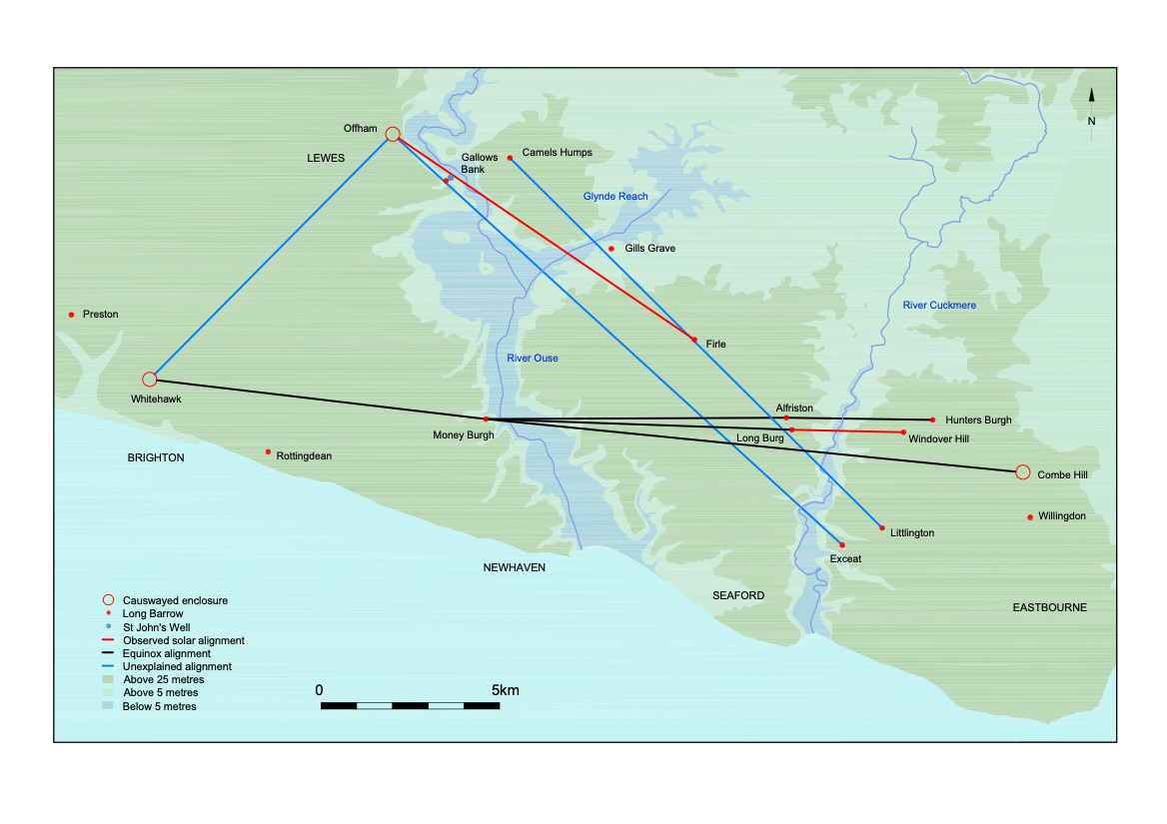
Figure. 2. Possible solar and other unexplained alignments

As shown in Figure 2 the mid-winter sun may rise from the position of Firle long barrow, which is 205 metres above sea level, when seen from the Offham enclosure, at only 90 metres above sea level. This difference in altitude means that the corresponding mid-summer sunset overshoots Offham when observed from Firle. At the solstices, or solar standstills, the positions of sunrise and sunset on the horizon barely alter over a period of about two weeks when assessed with the naked eye, so it should be possible to witness midwinter sunrise on at least one day without cloud cover during the relevant period. In contrast, at the equinoxes the sun’s position on the horizon changes markedly from day to day, and some of the Neolithic monuments, especially the two close-set Alfriston barrows seem positioned to extend opportunities to witness the transition of sunrise from one range of hills to the next at this significant change in the seasons.

Five days before the equinox, the sun can be seen from Alfriston oval barrow rising at the junction between a distant ridge and the foot of Windover Hill. By walking some 50 metres downhill towards the Long Burgh an observer can guide the sun over the hill’s profile to the position of Windover long barrow. By continuing to walk along the top of the Long Burgh, or parallel to it, the observer can then keep the sun on the horizon until it lifts off from about the direction of the Combe Hill enclosure on the next block of downland. At the equinox proper the Long Burgh may offer a direct view of sunrise over the Windover barrow, but the closeness of the two Alfriston barrows suggests that manipulating sunrise possibly had ceremonial value here, perhaps as an attempt to influence the coming season’s weather. Whitehawk also faces the equinox dawn. The enclosure extends 250 metres from north to south along a crest running parallel to a succession of distant blue ridges with the small summit of either Windover or Firle near the centre. The sun rises in the notch beside this summit at or around the equinox depending on where an observer stands within the enclosure, so there is some leeway to adjust the sun’s position if circumstances such as adverse weather require it. It could take several years of observations combined with well-orchestrated teamwork to work out the precise sequences to obtain the best results.

At around the equinoxes, the full moon would be observable annually on one night only if the weather allowed it, in positions on the horizon similar to those of the sun, whereas at the winter and summer lunar standstills the positions would change from year to year in accordance with the 18.6 year cycle.

An indication that the equinox mattered in the positioning of the monuments seems evident from the alignment between Money Burgh, Alfriston oval barrow and Hunters Burgh. It runs almost precisely due east to west, reflecting the positions of sunrise and sunset if seen in a flat landscape with flat horizons, or at sea level. The great majority of the alignments shown in Figures 2 and 3 are similarly schematic, apparently representing the pure geometry of the skyscape rather than observable conditions among the hills with monuments positioned at varying altitudes. The alignments would not run true if they depended on skyscape events being visible along a line of sites at the same time on any one day. This is particularly apparent in the splay of alignments from Money Burgh to Hunters Burgh, Windover Hill and Combe Hill respectively. A fourth possibly relevant straight alignment, running from the Preston barrow, via Alfriston oval barrow to Windover is not illustrated for space reasons. Such variations make it difficult to predict when and where other observable alignments may occur, especially if spectators may need to move about to fully appreciate interactions of the skyscape with the landscape.

Since the possible astronomical significance of most of the alignments in Figures 2 and 3 has not yet been identified they are shown here as geometric shapes with a stress on their repetitive elements. In Figure 2 the two diagonals running from Offham to Whitehawk and to Exceat meet almost at a right angle, a symmetrical 45° degrees either side of due north, except that the eastern line is about two degrees out. Its near parallel from the Camel’s Humps to Litlington would form a more convincing right angle with the western line.
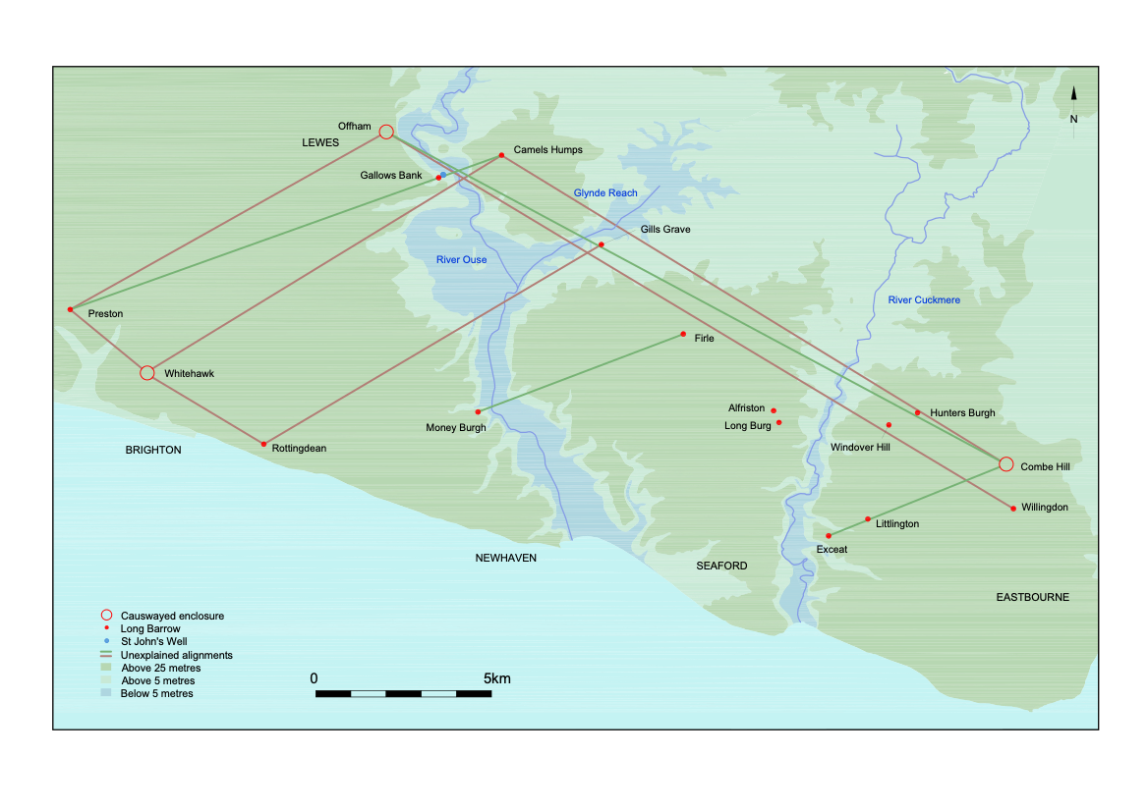Figure 3. Parallel alignments

Figure 3 indicates parallel and near parallel alignments that form complete or part- parallelograms focused on the estuaries. The most striking of these is the almost precise parallelogram shown in brown, that links the Camel’s Humps, Whitehawk, Rottingdean and Gills Grave. Its alignments run broadly from 59°NE to 239°SW, and from 122°SE to 302°NW. The upper part of this figure frames the widening out of the Ouse floodplain between Lewes and the confluence with Glynde Reach, an area regularly transformed into an inland sea at high tide well into the medieval period. There is a sub-parallelogram with somewhat convergent long sides to the west, and a similar, more elongated one to the north. This crosses the Ouse, Glynde Reach and the Cuckmere at the narrows where the rivers leave the Weald and start to thread their way through the Downs.

The three shorter alignments shown in green in Figure 3 are more precisely parallel, running from 70°NE to 250°SW, and are equidistant apart. The westernmost one and another long alignment, that may link them to the north, each divide one of the brown sub-parallelograms diagonally. Assuming there was a southern corner to this assemblage of green and brown figures, it probably emphasised the mouth of the Ouse where it once converged with that of the Cuckmere, before their confluence was destroyed by coastal erosion.

Confronting the Tides

At least one monument, Money Burgh seems to focus primarily on the landscape’s interaction with the water rather than the skyscape, although the moon and sun’s control of the tides remains a factor. The sun’s influence is less obvious than that of the moon, but it can sometimes be noticeable in the early morning and evening when the turn of the tide in the rivers can be delayed significantly to coincide with sunrise or sunset over a neighbouring hill. For example, at appropriate times at the Winterbourne outfall at Lewes all the currents in the Ouse do not fully turn up as the tide comes in until the rising sun appears over nearby Cliffe Hill, which looms quite closely over the river. Possibly considerations of this sort influenced the positions of some monuments in ways that are now difficult to predict.

Money Burgh has no obvious observable alignment with the skyscape on significant dates, although it is distinguished by three concentric circles. Its importance seems due to its striking view of the full southern stretch of the Cliffe Hills across a wide sweep of the estuary. From this perspective the isolated hill formation looks in outline like a crouching quadruped, of a rather reptilian cast confronting the incoming tides. The small but distinct peak of Caburn, ringed with much later ramparts, is at the head, the Ranscombe shoulder forms the foreleg, with the rear haunch at Southerham and a substantial tail sloping down towards the Malling peninsula. This may be an instance of pareidolia, where the shape of one object is strongly suggestive of another in ways that can have profound religious significance for some people, like seeing the face of Christ in improbable contexts. To prehistoric minds the giant creature, represented by the Cliffe Hills may have possessed divine agency, counterbalancing that of the moon and sun, to check damaging incursions of all but the highest seas. The barrow on private land is not easily accessible, but a similar view can be seen, significantly perhaps from mid-river, from Southease bridge.

Gill’s Grave, the quarried away barrow above Glynde Reach, viewed the hill formation from the eastern side. Nowadays, from a lower perspective only part-way up the quarry rim, the animal outline is less pronounced, but Caburn rears up impressively at the head. There is the same contrast here between near and distant views that was apparent among alignments linked to the equinoxes. The snaking rivers too have reptilian outlines, which grew more pronounced from the early Neolithic as meanders formed, due to soil erosion from limited woodland clearance and small-scale agriculture, which was already beginning to silt up the river valleys. The Ouse’s meanders were largely destroyed by post medieval canalisation but show up well in outline beside the river on Ordinance Survey maps. The Offham enclosure still overlooks an impressively winding stretch of river which gleams attractively in the dawn light and leads the eye towards the midwinter sunrise.

Conclusions

Overall, there is too much repetition among the alignments, and in the focus of some individual monuments on the landscape’s interaction with the rivers, tides and the skyscape for them to be coincidental. The circles add a new dimension, drawing attention to the many properties of water, and to a surprising prehistoric capacity for two-dimensional mapping, which may have developed under clearer skies in flatter landscapes at the start of the Neolithic. This skill may have enabled communities to adapt to new environments as Neolithic cultures spread across Europe and eventually Britain, but Mesolithic understanding of local topography and the seasonal changes in position of the sun and moon on the horizon may also have played a part.

Dense tree cover need not have been an obstacle and may have been an advantage. At most of the distances involved woodland would barely distort the outlines of the hills, and trees would provide excellent bases for viewing platforms high in the canopy. Selective felling might even create corridors among the trees along which the beams of the rising and setting sun and moon could be directed on auspicious dates, much as those effects were deployed in later monuments built elsewhere in stone, such as Stonehenge and Maes Howe. The estuaries too would provide good sightlines among the wooded hills.

Possibly this part of Sussex had an unusual number of the natural phenomena that prompted a concentration of monuments in curiously precise patterns during the Early Neolithic. Overall, the alignments seem testimony to a belief system that was attempting to maintain a balance between the divine order of the skyscape, the irregularities of the terrain, and the unreliable nature of water with its range of obvious benefits and potential threats. It was present in the sky as useful rain or adverse weather, at ground level it was essential to the infrastructure of settled life including stock raising, hunting, fishing and fowling, as well as for communication and transport but flooding and soil erosion could seriously disrupt this, while the sea constantly gnawing at the chalk cliffs threatened even the solidity of the hills. Water also emerged from the underworld as pure or healing springs but it had inherent dangers once polluted, or as stagnant, unstable bogland.

This initial analysis of the alignments was attempted without conscious reference to more mainstream archaeological approaches, but in some respects, it accords surprisingly well with Steve Sutcliffe’s 2016 outline of the local Neolithic [8]. The circles’ northern emphasis on Sharpsbridge and Newick coincides with the two main Neolithic findspots in that area. Evidence of widespread woodland clearance at Whitehawk, compared to limited felling at Offham and Combe Hill, matches the perception that the whole length of the Whitehawk enclosure may have served for observations of equinox and other sunrises along the distant downland ridges to the east. The impression that landscape features such as the Caburn were possibly regarded as monuments, can probably be amplified if it is accepted that the entire range of Cliffe Hills rather than just the imposing summit was considered not only as a monument but as a proactive element in the landscape. Similarly, while the rivers and their uses are an obvious focus, the pattern of alignments seems to direct attention to more diverse aspects of water, possibly even including reflections, than are generally apparent in archaeological contexts.

Proper scientific assessment of the alignments described here is now needed. This is beyond Lewes Archaeological Group’s present capabilities, but it is hoped that our 2021-2 lecture season’s focus on skyscape archaeology may help raise awareness of the subject and lead to better links with those doing relevant research, and with local astronomers.

I am most grateful to Justin Russell for producing the maps in this article, and to Lewes Archaeological Group for meeting the cost, and also to all those who have encouraged me in this project.

©2022 Fiona Marsden

Notes

1. The Park and Pool, F.Marsden, pp 24-38,The Pells of Lewes, ed. R. Thomson and S. Bayliss, Lewes History Group [2020]
2. A Romano-British(?) Barrow Cemetery and the Origins of Lewes, J. Bleach, Sussex Archaeological Collections vol. 135 [1997] pp 131-42.
3. The Upper Ouse Navigation 1790-1868, D.F.Gibbs and J.H.Farrant, Sussex Industrial History No.1 [1970] pp 22-40.
4. Two Probable Hundred Moot Sites, W. Budgen, Sussex Notes and Queries vol. II [1929] pp 210-14.
5. Living on the Margins? The Late Bronze Age Landscape of the Willingdon Levels, C. Greatorex, pp 89-100, The Archaeology of Sussex to AD 2000, ed. D. Rudling, University of Sussex 2003.
6. South Downs Beachy Head to the River Ouse: Aerial investigation and mapping: archaeological report. E. Carpenter, M. Barber and F. Small, English Heritage Research Report Series 22 [2013] pp 9-13.
7. Barrow Formerly Existing in Preston Drove, Brighton, F.G.S.Bramwell, Sussex Notes and Queries vol. VII [1934] pp 73-6.
8. Archaeology of the Ouse Valley, Sussex, to AD 1500, Ed. Dudley Moore, Michael J. Allen and David Rudling, pp 37-44 Archaeopress, 2016.

